IP Camera

Smartphone -ready colour night/day

network camera with pan, tilt and zoom
DYN-C500

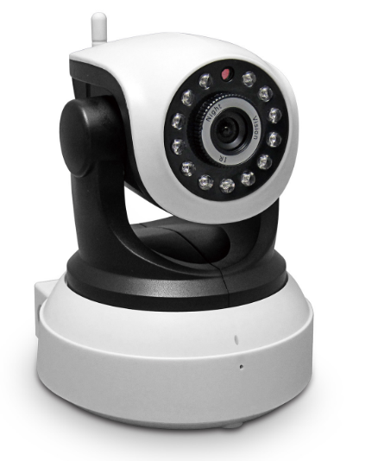

Introduction:
The 631GB series is the new H.264 Plug and Play indoor IP Camera. Once you connect camera to internet, no need any setting, you can see anywhere, any place, via manufacturer Mobile phone and PC and tablet software to view what you care for!

One key wifi setting. No need network cable, use your mobile help IP Camera connect with WIFI.
Support 64G SD card socket for recording storage;
Have Widows PC client and Mac pc client;
P2P, Plug and Play;
1.0 Mega pixels CMOS lens;
Support PIR detection;
Support two way intercom; Build-in Mic and loudspeaker;
631GB +Mobile/Tablet/PC +iSmartViewPro =3 steps Install;
Support 3 kinds of H.264 video stream and 1 way MJPEG video stream; Simultaneously, suitable for Local, Internet and Cross-platform view;
Support resolution for 1280*720/640*360/320*180; 720P HD;
Support 4 ways view in a video stream;
Support 802.11b/g/n protocol, build-in WiFi module to perform wireless monitoring;
Support rotate 350° horizontally and 90° vertically;
Built-in IR_CUT, 3.6 mm lens; 12pcs IR LED, up to 8meter night vision;
Built-in web server, use one port to send all the data, users can facilitates network setting;
Support ONVIF and RTSP protocol, easy to integrate it to NVR or large client software;
Support WPS/QSS function;
Support POE function, user optional;
Support multi-languages web interface, support multi-screen to perform several view at same time;
Manufacturer puts a label of DDNS at the bottom of each IP Camera. When IP Camera is connected to the internet, this URL can be used to visit the device;
Provide free client software, support Multi-view, Long time recording, video replay etc;
Motion Detection,
Audio detection and Audio alarm.

Specification
Model | 631GB
Hardware performance | Product type | IP camera
Hardware performance | Operation system | Embedded operating system
Hardware performance | Special function | One key WIFI setting; Support 64G SD/TF card; have Mac PC client.
Web environment | Web protocol | TCP/IP、UDP/IP、HTTP、SMTP、FTP、DHCP、DDNS、P2P、UPNP、NTP、RTSP、ONVIF
Web environment | LAN port | 10Base-T/100Base-TX
Web environment | Wifi | WIFI，802.11 b/g/n
Image performance | Resolution | 720P、640*360、320*180
Image performance | Compression mode | H.264/M-JPEG
Image performance | Max frame rate | 30fps
Other parameters | Lens | f=3.6mm, F=2.0
Other parameters | Min. illumination | IR on, 0 Lux
Other parameters | Electronic shutter | 1/50s(1/60s)-1/100,000 s
Other parameters | SNR | 48db
Other parameters | Safety performance | Three levels of user rights
Other parameters | Install mode | Wall-mounted / ceiling-mounted
Other parameters | Other performance | PC software,support for Microsoft Windows 98/2000/XP/Vista/Windows 7/Mac OS,And the Internet Explorer6.1 and above version or browser compatibility, Firefox, etc.,  provide iSmartViewPro client software
Other parameters | Power supply | DC 5V
Other parameters | Sensor | CMOS Sensor
Other parameters | IP camera performance | Support video control, Two-way voice talkback, motion detection, external alarm(sends information to alarm the server by Email, FTP);  Manufacturers provide free DDNS, and has been written into equipment;  12pcs IR LEDs,8 meters effectively;  Platform level angle 350 °,90 °vertical angle;  automatically control through the photoresistor;
Other parameters | Audio input | With microphone
Other parameters | Audio output | With speaker,  Provide the audio output interface
Other parameters | Alarm in | Not supported
Other parameters | Alarm out | Not supported
Other parameters | Power consumption | Power<6W
Appearance parameters | Body size | 105*116*126mm
Appearance parameters | Product weight | 0.40kg
Environment parameters | Environment temperature | -10℃~50℃
Environment parameters | Environment humidity | below 85% RH

Packing List
1, IP Camera* 1
2, Driver and tool CD *1
3, Network Cable*1
4, 5V Power Adapter *1
5, Wi-Fi Antenna*1
6, Bracket * 1

